
Omar Ahmed 221010780
Farid Hadi 221001437
Mohaned khaled 221011513
Amjad Khaled 231002527 ENG: Salma Nagy
Dr: Hagar Hussein

Chapter 1 — Introduction to AI

Brief Introduction to AI Techniques
Artificial Intelligence (AI) refers to computational techniques that allow machines to mimic human intelligence. AI techniques can be divided into:
    - Machine Learning – models learn patterns from data.
    - Deep Learning – neural networks with many layers that automatically extract features.
    - Natural Language Processing (NLP) – understanding human language.
    - Computer Vision – enabling systems to “see” and
interpret visual information.
    - Expert Systems – rule-based reasoning systems.
In this project, the chosen AI technique is Deep Learning (Convolutional Neural Networks – CNNs) for image classification.

Image Detection & Image Recognition (Detailed)
Image Detection (Object Detection)
    - Identifies where objects are in an image.
    - Outputs bounding boxes + class labels.
    - Example: detecting multiple dogs in a park.

Image Recognition (Image Classification)
    - Determines what the image contains.
    - Outputs a single label for the entire image.
    - Example: “This image is a Cat” or “This image is a Dog.”
Our project uses Image Recognition because each image contains only one object (cat or dog).

Pre-trained Models
Pre-trained models are deep-learning models that were already trained on massive datasets (e.g., ImageNet with 14+ million images). Examples:
    - VGG16
    - ResNet
    - MobileNet
    - Inception Benefits:
    - Faster training
    - Higher accuracy
    - Less labeled data required
    - Reduce computational cost
Although our project uses a simple CNN, we could improve accuracy using a pre-trained model (Transfer Learning).

Objectives of the System
- Classify images into Cat or Dog using a CNN model.
- Train the model using the TensorFlow Cats vs Dogs dataset.
- Measure model performance using:
  - Accuracy
  - Precision
  - Recall
  - F1-score
  - Confusion matrix
- Build a reliable intelligent system capable of image-based decision-making.

Elements of the Intelligent System
- Meaningful Experience
The system learns patterns from 20,000+ cat and dog images through training.
Experience = training data + model weights updated continuously.
- Implementation of Intelligence
The CNN model performs:
  - Feature extraction

  - Pattern recognition
  - Classification decision
The intelligence is implemented using TensorFlow/Keras.
- Intelligence Creation
Intelligence is created through:
  - Data preparation
  - Model architecture design
  - Training process
  - Evaluation
  - Continuous improvement

AI Selection Problem
To select the correct AI method, we ask:
- What is the input?
Images → high dimensional → needs deep learning.
- What is the task?
Binary classification → Cat or Dog.
- What constraints exist?
- Not too heavy → simple CNN is enough.
- Dataset is large → neural networks preferred.

Conclusion:
CNN (Deep Learning) is the best choice.

Compare Chosen Technique with 2 Others
Technique Pros Cons

CNN (chosen) High accuracy for images, automatic feature extraction
Requires GPU for best speed

SVM (Support Vector Machine)
Works on small datasets Requires manual feature extraction

KNN (k-Nearest Neighbors) Simple to implement Very slow on large datasets

Why CNN is chosen?
Visual data requires feature extraction → CNN learns this
automatically
High performance on image tasks Scales well to large datasets
Works better than classical ML techniques

Chapter 2 — Quality Characteristics

Qualities Presented in Your Code
    - Modularity → model, preprocessing, evaluation separated
    - Reusability → functions reusable
    - Scalability → dataset can grow
    - Maintainability → clean workflow, easy to extend
    - Reliability → monitored by accuracy, precision, recall

System Goals
    - Accurate classification between cats and dogs
    - Efficient training process
    - Reliable predictions on new images
    - Low false positives/false negatives
    - Fast execution inside Google Colab

Cost and Quality of Data
    - Dataset is free (TensorFlow Datasets) → low cost
    - High image quality → improves learning
    - Large dataset → prevents overfitting
Quality issues can include:
    - Blurry images
    - Wrong labels
    - Varying lighting
    - Different resolutions

AI Canvas
Problem: Classify cats vs dogs
Input: RGB images
Output: Label (Cat / Dog)

Model: CNN
Success measure: Accuracy, F1 Users: Developers, students, testers Data: 20k labeled images

Success Measures
Measured through:
    - Accuracy
    - Precision
    - Recall
    - F1-score
    - Confusion matrix

Quality Attributes
    - Accuracy → how well predictions match reality
    - Robustness → stable results
    - Generalization → ability to classify unseen images

Constraints
    - Limited GPU time in Colab
    - Limited dataset size
    - 150×150 image resolution to save memory

    - Binary classification only

Quality/Confidence in Prediction Diagram
Confidence is shown by:
prediction = model.predict(image)

If result = 0.97 → model is 97% confident.
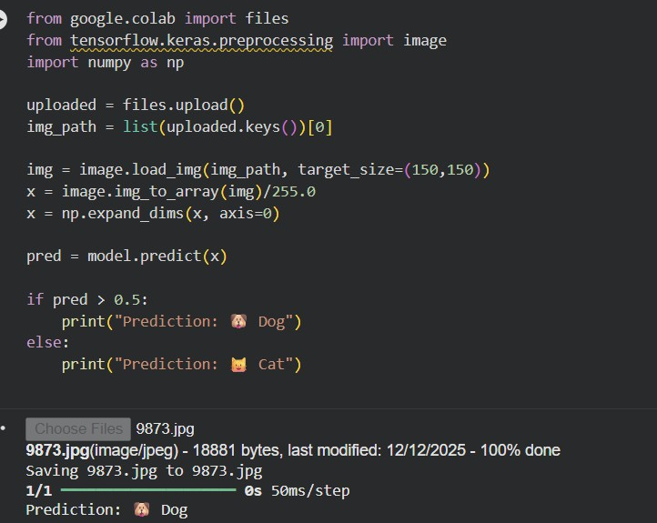

How to Check Data Quality?
    - Visual inspection
    - Remove corrupted images
    - Ensure correct labels
    - Consistent image sizes
    - Balanced classes

Data Challenges
    - Noisy data
    - Mislabeling
    - Different lighting/backgrounds
    - Some classes harder to distinguish

Chapter 3 — Machine Learning

Forms of ML
- Supervised Learning
Model learns from labeled data.
  - Classification

Predict categories (Cat / Dog).
Our project uses this.

  - Regression

Predict continuous values (prices, temperatures).

- Unsupervised Learning
No labels → clustering and dimensionality reduction.

- Reinforcement Learning
Agent learns from rewards/punishments.

Selecting a Form of ML
Since labels (“Cat”, “Dog”) are available → Supervised Classification is required.

Overfitting and Underfitting
Overfitting
Model performs excellent on training data but poorly on new data.
Cause:
    - Too many layers
    - Too long training

Fix:
    - Dropout, data augmentation, early stopping
Underfitting
Model is too simple → performs poorly on both training and
testing data. Fix:
    - Add more layers
    - Train longer

ML Workflow
- Define problem
- Collect data
- Preprocess data
- Split train/test
- Build model
- Train
- Evaluate
- Deploy

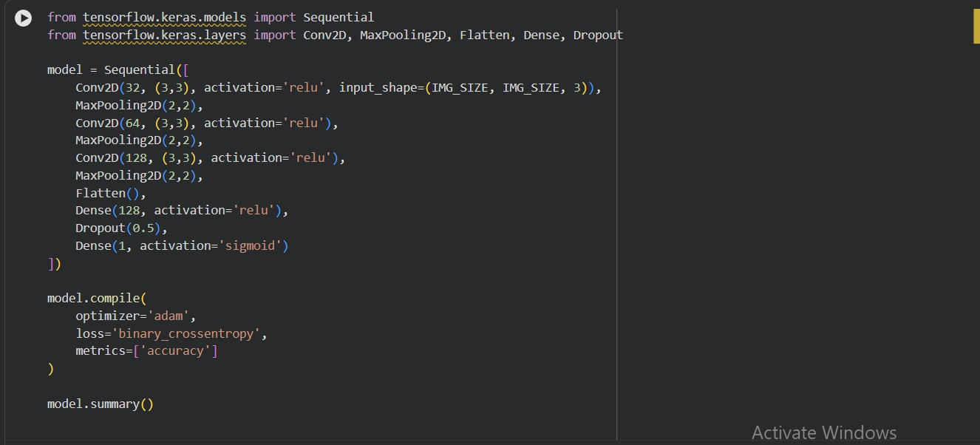

Chapter 4 — ML Data

Data Preparation
Include your code screenshots for:
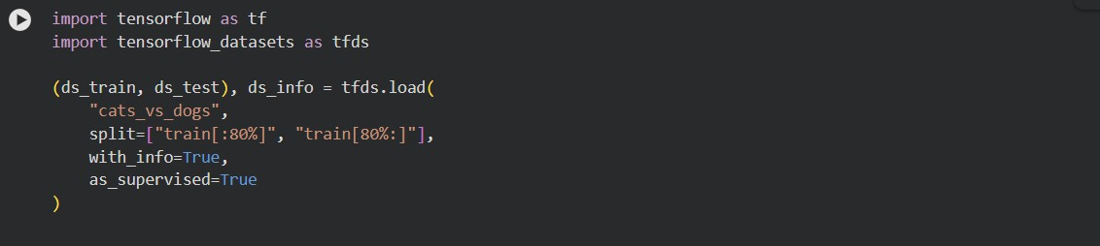
    - Loading dataset

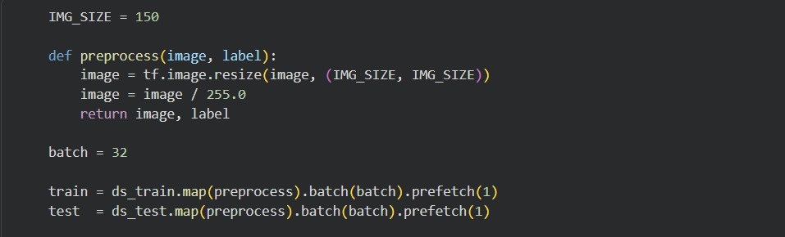
    - Preprocessing

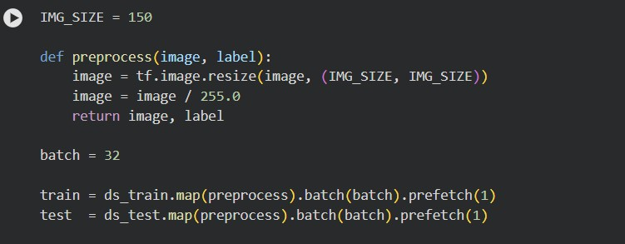
    - Normalization (image / 255.0)

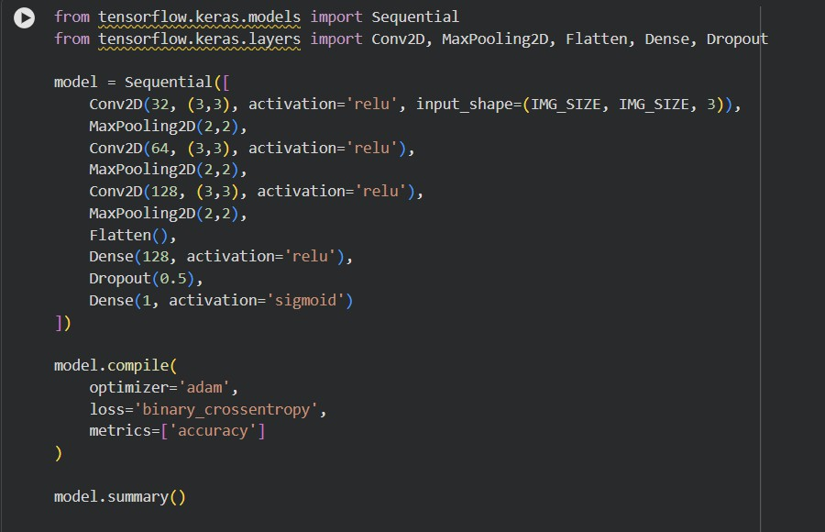
    - Building CNN

    - Training loop

    - 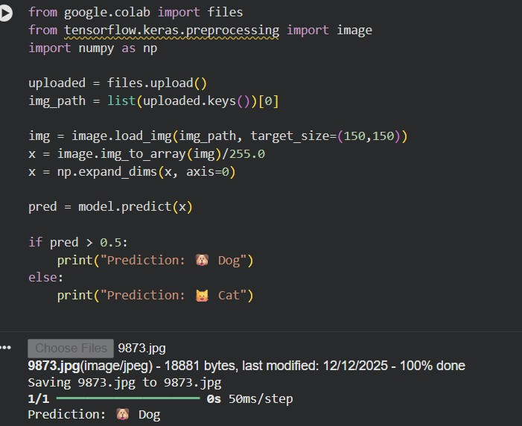
    - Evaluation metrics

    - 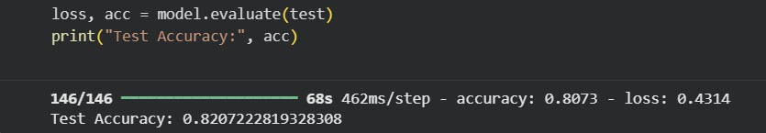
    - Confusion matrix

    - 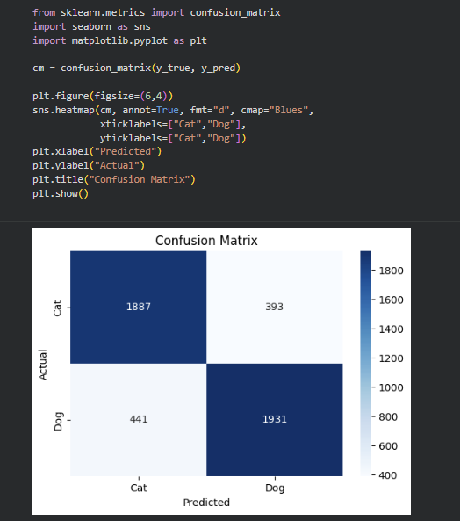

Dataset Quality Issues
Possible issues:
    - Blurry images
    - Wrong labels
    - Different image size

    - Noise in background

ML Accuracy and Performance
Measured using:
    - Accuracy from model.evaluate()
    - Confusion matrix
    - Precision, Recall, F1
    - Loss curve (optional)

Data Labeling for Supervised Learning
In TensorFlow dataset:
    - 0 → Cat
    - 1 → Dog
Labels provided automatically → no manual labeling required.

Chapter 5 — (ML Performance Metrics)

4.a Measure Prediction Accuracy by Confusion Matrix. Explain TP, TN, FP, and FN.

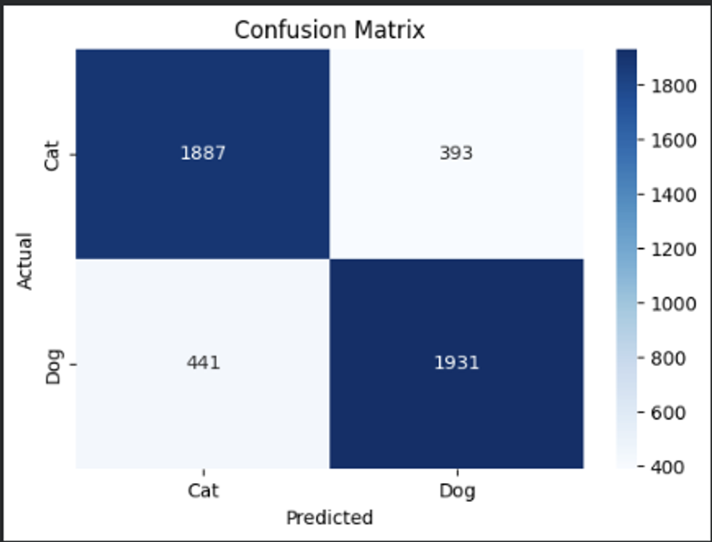

For cat and dog image classification model, the confusion matrix contains 4 elements

True positive : the model correctly predicts an image as a dog when it is actually a dog

True negative : the model correctly predicts an image as a cat when it is actually a cat

False positive : the model predict an image as a dog while it is actually a cat

False negative : the model predict an image as a cat while it is actually a dog

When using thesr value, prediction accuracy and other metrics like precision, recall, and fi score are calculated to evaluate how well the model performs on unseen test data

4.b Limitations of ML Functional Performance Metrics.
They have several limitations
- Accuracy can be misleading when the dataset is wrong
- Metrics do not explain why the model makes certain mistake
- They do not measure model strength against noisy or unseen data
- Functional metrics alone cannot assess system reliability or risk in real word environments
so we should be combined performance metrics with qualitative analysis and testing strategies

4.c Why Automation testing can be applied?
Automation testing is essential for machine learning systems because:
- It allows continuous testing after model updates or retraining.
- It reduces human errors during repeated testing processes.
- It ensures consistent evaluation of model performance.
- It helps detect performance ruin early.
- It saves time and effort when validating large datasets.
In our project, automation testing can be used to automatically evaluate the model after each training cycle using predefined test datasets.

Chapter 6 — (ML - Neural Network):

6.a Explain Neural network.

What is neural network?

A Neural Network is a machine learning model inspired by the human brain. It consists of interconnected layers of artificial neurons that process data and learn patterns.

Neural network contain :

Input Layer: Receives the input data

Hidden Layers: Perform feature extraction and pattern learning.

Output Layer: Produces the final prediction

In our project, a CNN is used, which is specifically designed for image related task

They are use convolutional layers to automatically extract important visual features like edges, shapes, and textures

Neural networks are suitable for image recognition because they:

Automatically learn features without manual extraction.

Achieve high accuracy on visual data.

Scale well with large datasets.

Chapter 7 — (Risk Analysis):

Risk analysis is a fundamental activity in software engineering for AI-enabled systems. Unlike traditional software, machine learning systems—especially black-box models such as Convolutional Neural Networks (CNNs)—can produce unpredictable and highly confident incorrect predictions. Therefore, risk analysis must focus not only on technical failures, but also on mistakes made by the AI model and their consequences.

Risk is defined as the combination of likelihood and impact. Effective risk analysis requires anticipating mistakes rather than assuming perfect predictions.

7.a Fault Tree Analysis (FTA)

Fault Tree Analysis (FTA) is a top-down, systematic technique used to analyze how a system failure (violation of a requirement) can occur as a result of combinations of lower-level faults. FTA is especially suitable for AI systems because it helps anticipate how model mistakes propagate into system-level failures and supports mitigation planning.

Top Event (Requirement Violation):

Violation of system requirement: incorrect or unsafe image classification output.

This event occurs when the system incorrectly classifies a cat as a dog or a dog as a cat, potentially producing a highly confident but wrong prediction.

Fault Tree Structure Overview

The top event can occur if any of the following major failure categories happen (OR Gate):

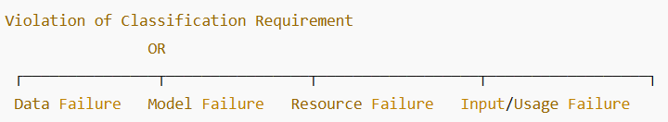

Each branch is decomposed into intermediate and basic events

Data-Related Failures (OR Gate):

Data issues are a primary source of risk in AI systems. If training data is flawed, the model may learn incorrect patterns and repeat the same mistakes consistently.

Basic Events:

Incorrect image labels in the dataset

Poor image quality (blurry or noisy images)

Imbalanced dataset between cats and dogs

Large variations in lighting or background

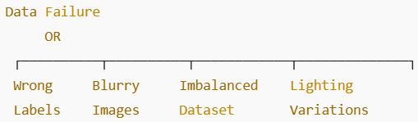

Any one of these basic events can lead to the top event.

Model-Related Failures (OR Gate):

Model design and training decisions can directly affect prediction reliability.

Basic Events:

Overfitting to training data

Underfitting due to a simple CNN architecture

Insufficient number of training epochs

Poor hyperparameter selection

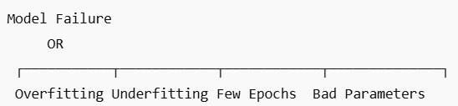

fixing one model mistake may introduce others, reinforcing the need for systematic risk analysis rather than assuming full correctness

Resource and Environment Failures (AND Gate):

In cloud-based environments such as Google Colab, failures may occur only when multiple conditions happen together.

Intermediate Event: Training interruption

Basic Events:

Limited or unavailable GPU resources

Session timeout during training

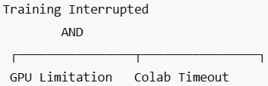

Both events must occur simultaneously to cause this failure.

Input and Usage Failures (OR Gate):

Even with a well-trained model, incorrect system usage can lead to failure.

Basic Events:

Input image not resized to the expected dimensions (150×150)

Missing normalization step during prediction

Corrupted or unsupported image format

FTA Summary

The Fault Tree Analysis:

Identifies how AI mistakes and technical failures lead to requirement violations

Helps prioritize high-risk contributors such as data quality and overfitting

Supports informed decisions about system redesign and mitigation

FTA is particularly valuable for AI-enabled systems because AI mistakes are unavoidable and unpredictable,

7.b Risk Mitigation Strategies

AI systems should be designed to accept the existence of mistakes and reduce their impact rather than assuming perfect predictions.

Risk mitigation strategies in this project include:

Using validation datasets to detect overfitting early

Applying confidence thresholds to flag uncertain predictions

Restricting predictions to data similar to the training distribution

Allowing human review of low-confidence or ambiguous outputs

These strategies reduce the consequences of incorrect predictions even when errors cannot be fully eliminated.

7.c Software Architecture for the Model

The software architecture reflects a simple academic machine learning pipeline, appropriate for the project scope and implementation.

TensorFlow Dataset→ Data Loading Module→ Image Preprocessing (resizing, normalization) → Train/Test Split → CNN Model (Convolution + Pooling + Dense layers) → Model Training → Model Evaluation (Accuracy, Confusion Matrix)→ Prediction Output (Cat / Dog).

Architecture Components Explanation

Data Source: TensorFlow Cats vs Dogs dataset

Data Loader: Loads images and labels automatically

Preprocessing Module: Resizes images and normalizes pixel values

Train/Test Split: Separates data for training and evaluation

CNN Model: Performs feature extraction and classification

Evaluation Module: Measures accuracy and error distribution

Prediction Module: Produces final classification output

This architecture supports traceability, testing, and risk analysis.

Chapter 8 — (Testing):

Testing is a crucial activity in software engineering for AI-enabled systems. Unlike traditional software, AI-based systems depend heavily on data quality, model behavior, and probabilistic outputs. Therefore, testing must address both machine learning–specific aspects and conventional software components.

8.a Testing Levels for AI-Based Systems

testing AI-based systems is performed at multiple levels to ensure correctness, robustness, and reliability.

1️- Input Data Testing

Input data testing ensures that the data used for training and prediction is of high quality and suitability.

In this project, input data testing includes:

Verifying that images are correctly labeled (Cat / Dog)

Checking image quality (no corrupted or unreadable images)

Ensuring consistent image size (150×150 pixels)

Ensuring pixel normalization is applied correctly

This level is critical because poor-quality data can lead to incorrect learning and unreliable predictions.

2️- ML Model Testing

ML model testing aims to verify that the selected:

Machine learning algorithm (CNN)

Model architecture

Hyperparameters

Training configuration

are appropriate for the problem.

In this project, ML model testing includes:

Evaluating training and validation accuracy

Detecting overfitting or underfitting

Measuring performance using a confusion matrix

This testing ensures that the CNN model performs optimally before integration with other components.

3️- Component Testing

Component testing is applied to non-model components of the system.

Examples in this project include:

Data loading functions

Image preprocessing functions

Model evaluation functions

Each component is tested independently to ensure correct behavior before integration.

4️- Component Integration Testing

Component integration testing ensures that AI and non-AI components interact correctly.

In this project, it verifies that:

Preprocessed images are correctly passed to the CNN model

Model predictions are correctly forwarded to the evaluation module

Evaluation metrics receive valid outputs from the model

This level focuses on data flow correctness between components.

5️- System Testing

System testing evaluates the complete integrated system in an environment similar to the operational environment (Google Colab).

System testing includes:

Running the full pipeline from input image to final prediction

Re-evaluating ML performance metrics

Verifying system behavior under different image conditions

This level ensures the system meets both functional and non-functional requirements.

6️- Acceptance Testing

Acceptance testing determines whether the system is acceptable for its intended use.

For this academic project, acceptance criteria include:

Achieving acceptable classification accuracy

Producing consistent and reliable predictions

Meeting project objectives defined in earlier chapters

Acceptance testing confirms that the system fulfills the expected learning outcomes.

8.b Selected Testing Technique

Pairwise Testing

Why Pairwise Testing?

Exhaustive testing of all input combinations is impractical

Pairwise testing reduces the number of test cases while maintaining high coverage

It ensures that every pair of input parameters is tested at least once

Suitable for AI systems with multiple input variations

Application of Pairwise Testing in This Project

For the image recognition system, possible input parameters include:

Image class (Cat / Dog)

Lighting condition (Bright / Dark)

Image clarity (Clear / Blurry)

Background complexity (Simple / Complex)

Instead of testing all possible combinations, pairwise testing ensures that every pair of these parameters is covered with a minimal number of test cases.

This approach improves testing efficiency while maintaining meaningful coverage of real-world scenarios.

